FIELD TRIAL TO EVALUATE THE AGRONOMIC EFFECTIVENESS OF
ZEOLITE ON TWO VEGETABLE CROPS UNDER GREENHOUSE
ENVIRODOME

DRAFT REPORT

PREPARED BY
PROF. SAMUEL ADJEI-NSIAH, AND DR. ALEX WILLIAMS AYARNA.

EXECUTING ORGANIZATION: FOREST AND HORTICULTURAL CROPS
RESEARCH CENTRE, UNIVERSITY OF GHANA, OKUMANING-KADE

PRINCIPAL INVESTIGATOR: PROF SAMUEL ADJEI-NSIAH

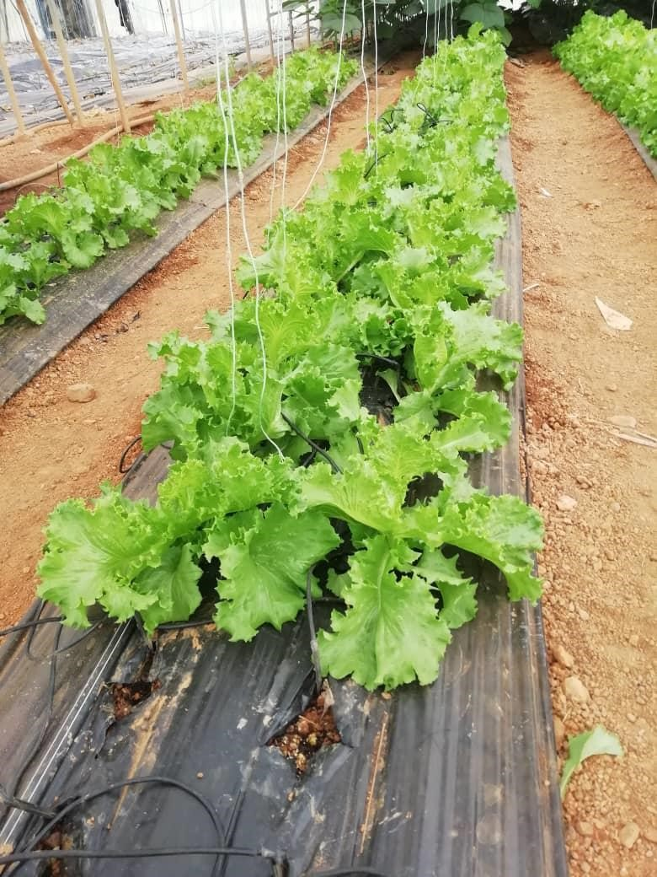

LETTUCE CUCUMBER

Executive Summary
Widespread use of chemical fertilizer causes serious environmental hazards as only a fraction of applied fertilizer is actually used by crop plants. The remaining amount of the nutrients applied is washed off resulting in high concentrations of potassium (K), nitrogen (N) and phosphorus (P) in surface water bodies or groundwater nitrates. This challenge can be resolved by using zeolite which has properties that promote nutrient retention capacities of the soil by improving the lower release of nutrients for uptake by crops. Zeolites also have the capacity of improving the moisture retention capacity of the soil and increasing crop yields in acidic soils. We evaluated the effects of zeolite application on the yield of two vegetables, lettuce, and cucumber under greenhouse envirodome conditions. The treatments evaluated were: 20 tons ha⁻¹zeolite + standard nutrient solution; 15tons ha¹zeolite + standard solution; 10tons ha⁻¹ zeolite + standard nutrient solution; 20 tons ha⁻¹ zeolite only and standard solution only. The results showed that the application of zeolite at the rate of 20 tons per hectare either alone or in a combination with standard nutrient solution for vegetables increased the yield of both lettuce and cucumber over the recommended standard nutrient solution for vegetables. The application of zeolite also resulted in soil moisture retention which resulted in both the increase in growth and yield of the vegetables. However, zeolite application resulted in lower brix for the vegetables probably due to higher N uptake and/or higher moisture uptake. It is recommended that a further study is conducted by combining Zeolite at 20 t ha⁻¹ with a reduced supplemented nutrient application rate. It is also recommended that the residual effect is evaluated on subsequent crops grown after the first vegetable crops have been harvested.

i

Table of Contents

Executive Summary ...................................................................................................................i
List of Tables ............................................................................................................................ii
List of Figures ...........................................................................................................................ii
Introduction ...............................................................................................................................1
Methodology .............................................................................................................................1
Results .......................................................................................................................................2

Soil properties of the experimental site………………………………………………………..2
Effect of zeolite application on growth, moisture retention and yield of lettuce ……………..2
Effect of zeolite application on growth, moisture retention and yield of cucumber…………..4
Conclusion……………………………………………………………………………………..6

List of Tables
Table 1: Treatments evaluated in experiment ……………………………………………….. 1
Table 2: Physico-chemical properties of the experimental site ------------------------------------2
Table 3: Effect of zeolite on soil moisture retention and growth of lettuce -----------------------3
Table 4: Effect of zeolite on leaf yield, Brix and dry matter yield of lettuce ---------------------3
Table 5: Effect of zeolite on nutrient uptake in lettuce ----------------------------------------------4
Table 6: Effect of zeolite on moisture retention and growth of cucumber ------------------------4 Table 7: Effect of zeolite on fruit yield, Brix and dry matter yield of cucumber……………...6

List of Figures
Figure 1: Photographs showing the performance of lettuce 2 weeks after transplanting…… 4 Figure 2: Photographs showing the performance of cucumber 30 days after transplanting......5

ii

Introduction

Widespread use of chemical fertilizers causes serious environmental hazards as only a small fraction of applied fertilizers is absorbed by crop plants. The remaining fertilizer is washed off into surface and underground waters. This results in high concentrations of potassium (P), nitrogen (N) and phosphorus (P) in surface water bodies or groundwater nitrates. These problems can be resolved by using zeolites. Zeolites promote nutrient retention capacity of the soils by improving the slower release of these nutrients for uptake by crops. Zeolite when used as soil amendments also have several other positive effects on the soil including soil moisture retention, increased hydraulic conductivity, and increased yield in acidic soils. Zeolite has been used in agriculture for increased soil water retention and improved nutrient availability for plant use Also, Zeolite increases soil nutrient use efficiency thereby reducing nutrient application rates and increasing crop yield.

Recently, a Zeolite (with a mineralogical composition of clinoptilolite, plagioclaz, anherite and cristobalite) has been introduced in Ghana by IMARICH VENTURES LIMITED for soil amendment practice. We evaluated the agronomic effectiveness of the Zeolite on two vegetable crops; lettuce and cucumber under greenhouse envirodome conditions for its importation, distribution and sales in Ghana.

Methodology
This study was conducted at the Forest and Horticultural Crops Research Centre of the University of Ghana, Kade, between February 14, 2022, and May 2, 2022, under greenhouse envirodome conditions.

Darina cucumber cultivar (Seminis Seed Company) and Eden lettuce cultivar (Technisem Seed Company) were used for the study. The plants were cultivated at a spacing of 1.3 x 0.3 m and 0.2 x 0.2 m for the cucumber and the lettuce, respectively.

The Zeolite product was incorporated into the soil according to the following treatments (Table1)

Table 1. Treatments evaluated in the experiment
Zeolite Application Rate (t ha⁻¹) + Standard Nutrient Recipe | Symbol
20 + 0.7 mM NH₄-N, 8 mM NO₃-N, 1.3 mM PO₄-P, 2 mM K, 2mM Ca, 1 mM Mg, 2 mM SO₄-S | SZ20
15 + 0.7 mM NH₄-N, 8 mM NO₃-N, 1.3 mM PO₄-P, 2 mM K, 2mM Ca, 1 mM Mg, 2 mM SO₄-S | SZ15
10 + 0.7 mM NH₄-N, 8 mM NO₃-N, 1.3 mM PO₄-P, 2 mM K, 2mM Ca, 1 mM Mg, 2 mM SO₄-S | SZ10
20 only | Z20
0+ 0.7 mM NH₄-N, 8 mM NO₃-N, 1.3 mM PO₄-P, 2 mM K, 2mM Ca, 1 mM Mg, 2 mM SO₄-S | S

Soil samples were collected and analyzed for the soil’s initial physical and chemical properties (Table 2).
Soil moisture retention was determined at the fruiting stage of the cucumber, using the TDR equipment. Soil water retention was measured (between 2 pm and 2.45 pm), after 28 hours of irrigation. Similarly, soil water retention was determined at two weeks after transplanting in the lettuce.

Some parameters measured were plant growth (height, leaf number), yield and quality (Fruit/Leaf fresh weight, Brix %) and crop productivity ( ^{Fruit Fresh Biomass} ).
Stover Fresh Biomass

Results

Soil properties of the experimental site
The initial soil characteristics and nutrient status are shown in Table 2. The soil used in the study was sandy loam. The nutrient content of the soil for vegetables was optimum.

Table 2. Physico-chemical properties of the soil at the study site
Property | Mean value
Sand (%) | 70.04
Clay (%) | 19.28
Silt (%) | 10.68
pH (water 1:1) | 6.28
Organic carbon (%) | 1.87
Total N (%) | 0.32
Available P (mg kg⁻¹) | 88.46
Exchangeable K  Exchangeable Ca  Exchangeable Mg | 1.194  3.6  1.8

Effect of zeolite application on growth, soil moisture content and yield of Lettuce The results on the effect of zeolite on soil moisture content and the growth of lettuce is presented in Table 3. An increase in Zeolite application significantly increased soil moisture retention in soil grown to lettuce. Soil moisture was higher in the SZ20 and Z20 than in the other treatments. An increase in the application rate of Zeolite significantly increased plant height, leaf number and canopy width of lettuce.

Table 3. Effect of Zeolite on Soil Moisture Retention and Growth of Lettuce
Application Canopy width
Rate (t ha-₁) Soil MC (mm) Height (cm) Leaf number (cm)

SZ20 | 50.74a | 18.5ab | 9.8a | 42.7a
SZ15 | 46.36ab | 17.3bc | 8.2b | 35.8b
SZ10 | 41.66b | 16.8c | 8.5b | 33.8b
Z20 | 52.46a | 19.5a | 9.2ab | 42.3a
S 41.34b 19.5a 8.7b 41.9a

The yield per plant and leaf dry matter of lettuce were significantly higher in the SZ20 than in the other treatments (Table 3). However, the sweetness (Brix %) was lower compared to the other treatments, probably due to sugar dilution from high soil moisture. Comparatively, this result may also be attributed to a higher nitrogen accumulation in the leaves of plants grown in the SZ20 treatments (Table 4). However, the accumulation of the other nutrients except for K in the leaf tissues was similar among the treatments.

Table 4. Effect of Zeolite on Yield, Brix and Dry Matter production in Lettuce
Application Rate (t ha⁻¹) | Yield (g plant⁻¹) | Brix% | Leaf Dry Matter (g plant⁻¹)
SZ20 | 94.45a | 3.1b | 3.78a
SZ15 | 48.67bc | 4.1a | 2b
SZ10 | 40.89c | 4.1a | 1.78b
Z20 | 80.44a | 3.9a | 2.78ab
S | 57.79b | 3.4b | 2.1b3

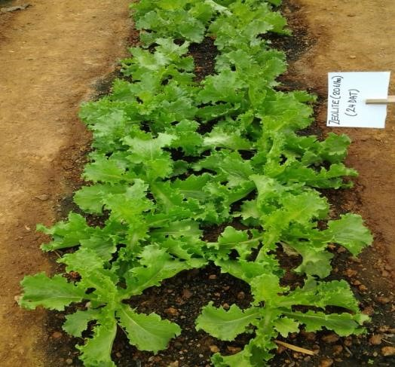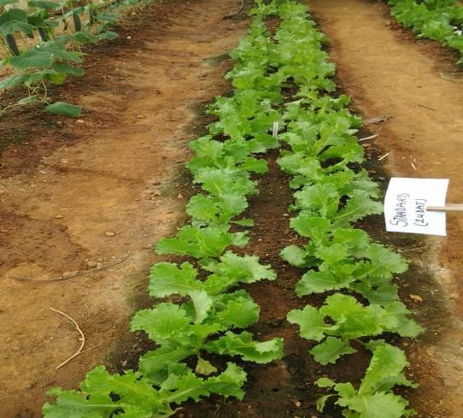

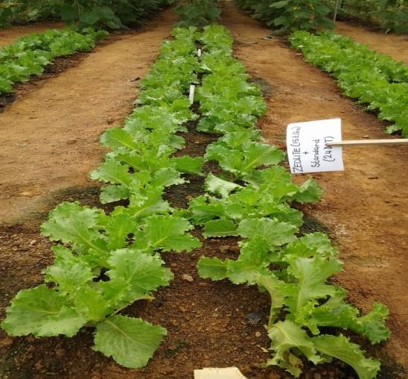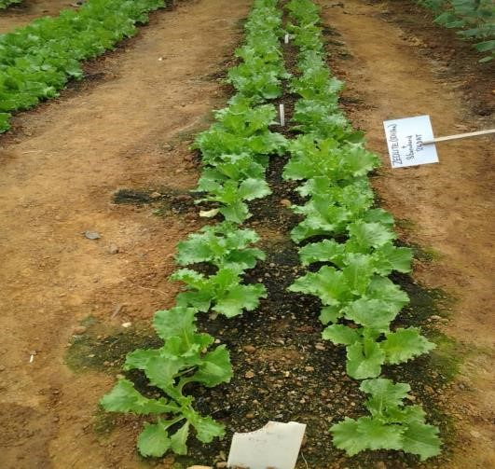

Figure 1. Effect of zeolite application on performance of lettuce two weeks after transplanting

Application of 20t ha⁻¹ zeolite either alone or in combination with the standard nutrient solution resulted in higher N and K uptake but lower uptake of Ca and Mg in the lettuce leaves (Table 5). P uptake was not influenced by zeolite application.

Table 5. Effect of Zeolite on leaf nutrient concentration in Lettuce (%)
Application Rate (t ha⁻¹) | N | P | K | Ca | Mg
SZ20 | 5.628a | 0.7563a | 6.192a | 2.254ab | 0.672a
SZ15 | 3.829b | 0.78a | 5.101b | 2.681ab | 0.76a
SZ10 | 4.157b | 0.7107a | 5.703ab | 3.121a | 0.808a
Z20 | 4.063b | 0.714a | 6.003ab | 2.027b | 0.64a
S | 5.184a | 0.7193a | 5.477ab | 2.274ab | 0.7a

Effect of zeolite application on growth, soil moisture retention and yield of Cucumber Soil moisture retention was significantly higher in the SZ20 and Z20 treatments than in the other treatments (Table 6). Plant height increased significantly for plants grown in higher dosage of zeolite but, days to fifty per cent flowering were not affected by the application of the zeolite. Leaf number produced per plant was higher in SZ20 than in the other treatments.

Table 6. Effect of Zeolite on Soil Moisture Retention and Growth of Cucumber
Application Rate (t ha⁻¹) | Soil MC (mm) | Height (cm) | Leaf  number | Days to 50% Flowering
SZ20 | 50.7a | 4.5ab | 61.7a | 16.3a
SZ15 | 46.34ab | 4.4ab | 47.7b | 16.7a
SZ10 | 41.64b | 3.9b | 44.7b | 16.6a
Z20 | 56.44a | 5.1a | 51.7b | 16.3a
S | 41.06b | 4.4ab | 45.3b | 16.3a

Both the number of fruits and fruit yield per plant were significantly higher in the SZ20 treatment than in all other treatments (Table 7). Comparatively, there was a reduction in the sweetness (brix) for fruits obtained from the SZ20 treatments. This observation may be associated with fruit sugar dilution arising from high soil moisture content (Table 6). Crop productivity was low in the SZ20 and Z20 treatments compared to the other treatments (Table 7). This might be due to the higher vegetative growth resulting from the high moisture retained in the soil for the SZ20 and Z20 treatments (Table 6).

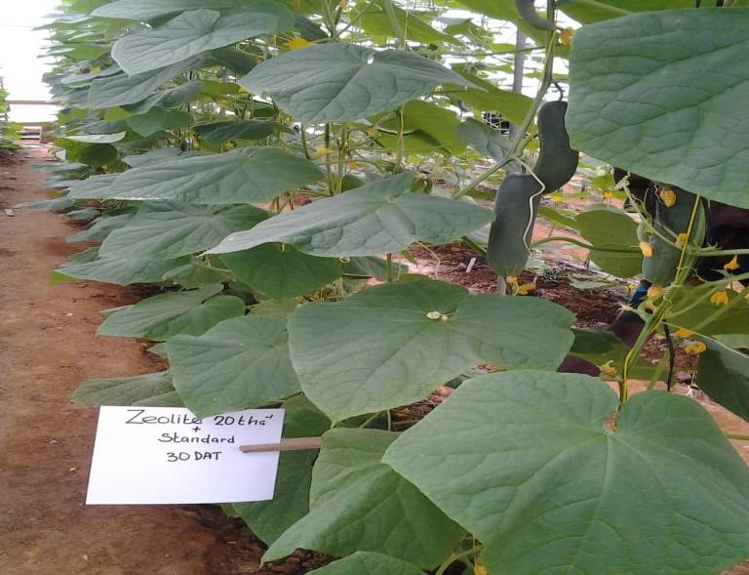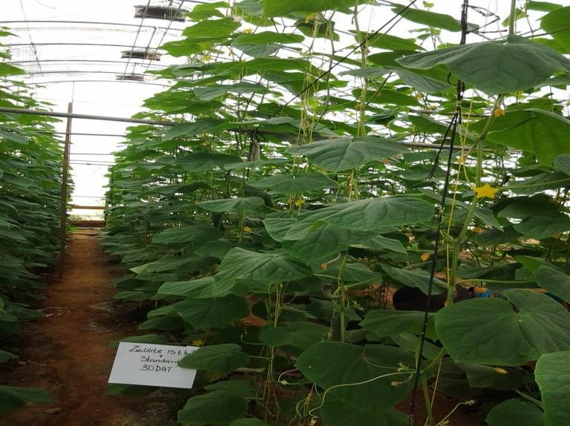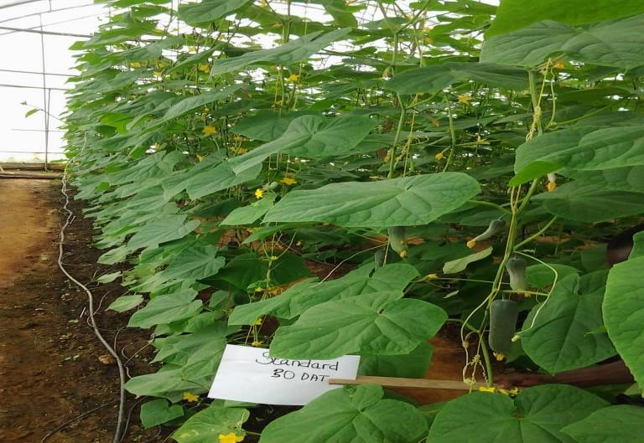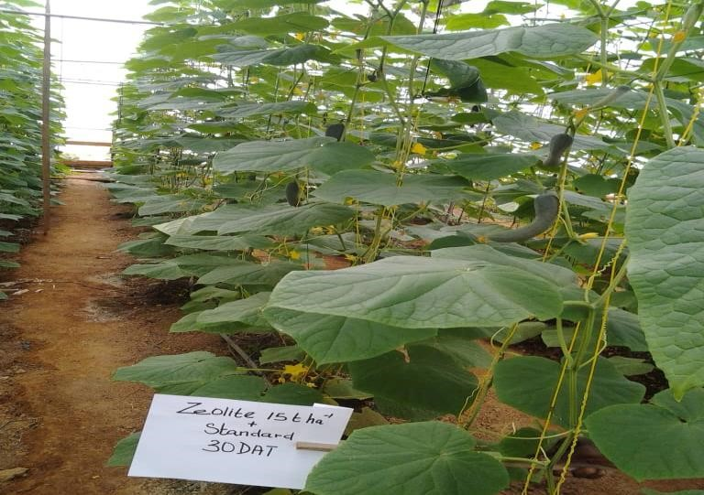

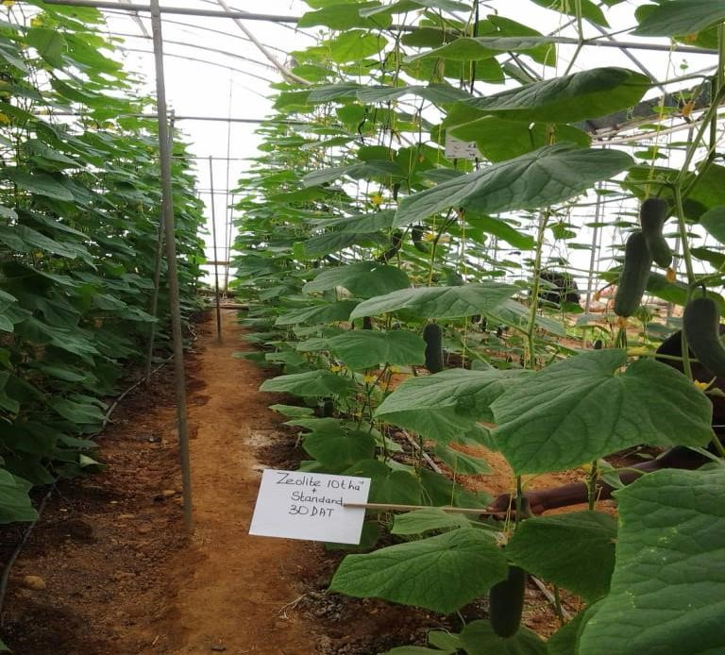

Figure 2. Effect of zeolite application on performance of cucumber 30 days after transplanting

Table 7. Effect of Zeolite on yield, Brix, Biomass and Productivity of Cucumber
Application Rate (t ha⁻¹) | Fruit number | Yield (g plant⁻¹) | Brix % | Plant productivity
SZ20 | 11.1a | 4629a | 2.9b | 1.9bc
SZ15 | 8.3c | 3933b | 3.2a | 2.7a
SZ10 | 8.8c | 3923b | 2.9b | 3.1a
Z20 | 9.8b | 3393b | 2.9b | 1.4c
S | 10.3b | 3893b | 3.2a | 2.4ab

Conclusions

Results from this study showed that Zeolite could be used as a soil amendment for increasing the yield of vegetable crops like lettuce and cucumber. Application of the product at 20 t ha⁻¹ improved soil’s water retention and increased nitrogen accumulation in leaf tissues of lettuce. It is recommended that the study is repeated to evaluate the residual effect of Zeolite on the subsequent crop that may be grown in rotation. To improve crop productivity in cucumbers, it is important to reduce high vegetative growth by reducing nutrients supplemented with Zeolite. In view of this, it is recommended that a further study is conducted by combining Zeolite at 20 t ha⁻¹ with a reduced supplemented nutrient application rate.

