Technical Report:

Field efficacy of SC Zeolite as an insecticide for the management of insect pests of leafy vegetables
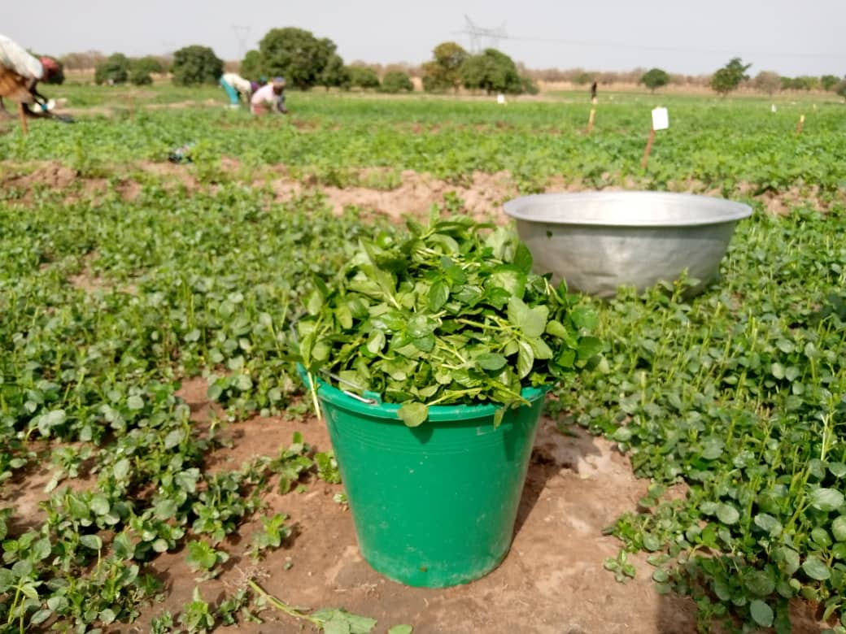
Submitted by

Dr. Francis Kusi
CSIR – Savanna Agricultural Research Institute (SARI)
P. O. Box 52
Tamale. Ghana
Email: onkufra@yahoo.co.uk; Phone: +233 244788076

May, 2022

Executive summary
Traditional leafy vegetables such as roselle (Hibiscus sabdariffa L.) and ayoyo (Corchorus olitorius L.) are important sources of micronutrients for many residents of sub-Saharan African countries including Ghana. This notwithstanding, the availability of such nutrient rich vegetables for consumption by households in rural and urban areas is limited by attacks by piercing and sucking insects as well as defoliators. Hence, a need to explore the potential of environmentally safe crop protection products for the management of these pests. This trial therefore evaluated the efficacy of SC Zeolite, an organic crop protectant, at field level for the management of insect pests associated with two leafy vegetables (i.e., roselle and ayoyo). The treatments tested comprised SC zeolite applied at different rates (0.13, 0.19, 0.25 kg/ha), neem seed oil (NSO) at a rate of 0.0.31 L/ha (positive control) and untreated controls. For each crop, fields of four farmers were selected. Thus, farmers served as blocks/replications. The field of each farmer was divided into five sunken beds each measuring 5 m x 5 m. Plants on each sunken bed were subjected to one of the five treatments trialed. The results showed that defoliators and sucking insect pests were major biotic constraints in the cultivation of the two vegetables used for this study. Major defoliators present included (Zonocerus variegatus) and beetles (Podagrica uniformis Jacoby, Ootheca mutabilis) while major sucking pests were whiteflies (Bemicia tabaci Gennadius (Hemiptera: Aleyrodidae)), leafhoppers (Empoasca sp. (Hemiptera: Cicadellidae)) and aphids (Aphis cracivora Koch (Hemiptera: Aphididae)). In general, the densities of defoliators in the SC zeolite treatments and the positive control (NSO) were lower than those recorded in the untreated control for both roselle and ayoyo trials. Protecting roselle and ayoyo with SC zeolite at 0.19 kg/ha was found to be the most effective dose which reduced infestation by defoliators. Increasing the dose of this product did not result in significant reductions in the densities of defoliator pests in these leafy vegetables. The effect of this product on sucking insects was significant in trial using ayoyo as test crop. The abundance of piercing and sucking insect pests was generally lower in the NSO and SC zeolite treatments but highest in the untreated control. Again, application of the test product at a rate of 0.19 kg/ha was identified as the most effective dose against this category of pests. The findings of this study therefore concludes that, SC zeolite is effective in mitigating defoliator and sucking arthropod pests damage in leafy vegetables cultivation. The recommended dose for this insecticide was found to be 0.19 kg/ha although at lower pests pressure this dose could be reduced to 0.13 kg/ha.
1.0 Introduction
A wide variety of traditional leafy vegetables (TLVs) are available in most African countries and these are used for food and medicinal purposes (Jansen Van Rensburg 2007). The TLVs are cost effective and represent a quality nutritional source of food for a large segment of the population in both rural and urban areas (from children to the elderly). There is currently a significant recognition of TLVs from government and research due to the introduction of the WHO (2009) strategy to increase consumption of fruits and vegetables to improve the well-being of the population.
For the poor in sub-Saharan Africa, dietary improvements with micronutrients are considered to be one of the most cost-effective methods of addressing poverty and its related problems. The major sources of essential micronutrients are TLVs. Indeed, TLVs have been identified as some of the richest and cheapest sources of vitamins such as vitamin A, thiamine, riboflavin, ascorbic acid, niacin, and minerals like calcium, iron, zinc, magnesium and phosphorus (Eyeson and Ankrah 1975). The potential of TLVs to offer significant opportunities for the rural poor and malnourished with cheap sources of balanced diet and to earn a living with very little investment have been established in a number of studies (Schipper 2000). In northern Ghana, TLVs provide important sources of food, nutrition and medicines for both urban and rural population.
A large variety of highly nutritious TLVs, such as Amaranthus cruentus., Talinum spp., Basella spp., Colocasia esculenta, Sesamum spp., Corchorus spp., Hibiscus spp., Manihot esculenta and Telfaira occidentalis (Abbiw 1990), are known to be available and used in some cultures. Unfortunately, access to adequate quantities of most of these nutritionally valuable leafy vegetables is not always guaranteed. This is because the existing potential for the intensive cultivation and utilization of TLVs is not exploited for a number of reasons. One of the key reasons is the plethora of defoliators and sucking insects that attack these crops from emergence up to harvest. Some major pest of leafy vegetables includes piercing and sucking insects such as Empoasca spp., Maconellicoccus hirsutus (Green), Aphis craccivora, Bemisia tabaci (Genn.), Oxycarenus hyalinipennis (Costa) and Earias insulana (Boisd.). Other important pests are defoliators such as Podagrica species and Zonocerus variegatus. These pests negatively impact yield of TLVs on farmers’ field. Hence, a need to identify effective but environmentally friendly crop protection measures to mitigate the effect of these pest.
The objective of this study was to evaluate the efficacy of SC Zeolite as an environmentally benign and effective insecticide for arthropod pest management in leafy vegetables on farmers’ field. To achieve the objective of this evaluation, two leafy vegetables were used as test crops. These were roselle, Hibiscus sabdariffa L. (family Malvaceae) and ayoyo, Corchorus olitorius L. (family Malvaceae).
2.0 Materials and methods
2.1 Study site
A field experiment was conducted at an irrigation site at Libiga in the Savelugu Municipality of the Northern Region to evaluate the effect of the SC Zeolite on insect pest infestations in vegetable cultivation. The climate in this zone is classified as Tropical Savannah climate with non-seasonal or dry-winter characteristics (Aw) in the Köppen – Geiger classification system (Geiger 1961). The annual mean precipitation in this region is about 1050 mm. The ecological zone has a unimodal rainfall pattern that falls from May to October of each year followed by a long dry period from November to April (Neumann et al., 2007).
2.2 Field layout and Experiment design
Roselle, Hibiscus sabdariffa L. (family Malvaceae) – Fields of four roselle farmers were selected at the Libiga irrigation site. The fields of the selected farmers were prepared by first spraying with a post emergence herbicide (Glyphander) to control weeds present. This was followed by using hand held hoes to manually prepare sunken beds of dimensions 5 m × 5 m. Each farmer represented a treatment block and thus, a total of five sunken beds which were 2 m apart were prepared on the field of each farmer.
The roselle seeds were evenly broadcasted on each treatment plot/sunken bed. The SC Zeolite treatments were applied at a rate of 0.13. 0.19 and 0.25 kg/ha. Neem seed oil applied at a rate of 0.31 L/ha was used as a treated control while untreated control plots were sprayed with water. The treatments tested were applied at 2 weeks after emergence and repeated one week later.
Ayoyo, Corchorus olitorius L. (family Malvaceae) – Four farmers were selected at the irrigation site at Libiga. They each prepared 5 sunken beds which were 2 m apart and of dimensions 5 m × 5 m. The farmers were used as replicate while the sunken beds on their fields were used as treatment plots. The seeds of “ayoyo” were evenly broadcasted on each of the plots. The SC Zeolite treatments tested were 0.13. 0.19 and 0.25 kg/ha, while controls comprised neem seed oil (applied at 0.31 L/ha) and an untreated control.
2.3 Preparation of insecticides for spray applications
The SC Zeolite was prepared by measuring 10, 15 and 20 g of the powdered product with a sensitive weighing scale. An empty crucible was first placed on the weighing scale and tared, after which a spatula was used to fetch the zeolite into the crucible until the desired weight was obtained. The content of the crucible was then emptied into a hand operated knapsack sprayer that was filled to half its capacity with water. The half-filled knapsack together with the product were rigorously shaken to obtain a homogeneous mixture. This was followed by adding water up to the 16 L mark and shaking again.
The neem seed oil (NSO) solution was prepared by measuring 10 ml of liquid soap into a half-filled knapsack and agitating to obtain a uniform mixture. Afterwards, 25 ml of the NSO was measured and poured into soap solution; this was again rigorously agitated to obtain homogeneous mixture. The knapsack was then filled with water up to the 16 L mark and shaken again before field application.
2.4 Trial management
Weed control in the trial fields were attained by hand pulling. This was done twice for both roselle and the ayoyo plots before harvesting. The fields were irrigated at three days interval.
Data collection
Data was collected at weekly interval on:
- Arthropod pests and natural enemies
- Insect pest abundance – this was done by inspecting all plants within a 1 m² quadrant; the quadrant was placed at 4 different random locations within each treatment plot.
- Natural enemy abundance – within each quadrant, the number of natural enemies (predators) present were identified and counted at each sampling.
- Damage assessment – all plants within the 1 m² were scored for percentage damage by arthropod pests. For defoliators, plants that had at least40% of their leaf surface areas eaten by defoliating insects were considered damaged and included in the data collected. For sucking pests, shrivelled leaves (for whiteflies) or browning of leaves (for leafhoppers) were some of the damage characteristics that were assessed. The average percentage of damage was computed by dividing the total number of plants that exhibited the symptoms described above by the total number of plants sampled and multiplied by 100.
- Phytotoxicity – during sampling, plants were visually inspected for damage due to the toxic effects of the insecticide trialed. This was done by counting the proportion of plants that exhibited characteristic symptoms phytotoxicity.
- Yield – at maturity, the quantity of leafy vegetable harvested from each treatment plot was weighed. The weight was then converted into yield per ha.
2.5 Data analysis
Data collected from the trials were subjected to a general analysis of variance (ANOVA). Prior to subjecting the data to the ANOVA, count and percentage data were square root transformed to ensure the homogeneity of their variances. In these analyses, insecticides were selected as treatment factors and the replications/farmers were selected as the blocking factor. Whenever there was a significant insecticide treatment effects, the means were separated using Fisher’s protected least significant difference at 5% probability threshold.
3.0 Results and discussion
3.1 Roselle (Hibiscus sabdariffa L.)
3.1.1 Insect pests’ densities
The insect pests recorded during this study were grouped into defoliators and sucking insects based on the nature of damage they cause to roselle plants. Defoliators comprised grasshoppers (Zonocerus variegatus), leafroller (Sylepta derogate), beetles (Podagrica uniformis Jacoby, Ootheca mutabilis) and semi-looper (Chrysodeixis acuta Walker (Lepidoptera: Noctuidae)). Of these, P. uniformis made up more than 60% of the defoliators recorded. The sucking insects were whiteflies (Bemicia tabaci Gennadius (Hemiptera: Aleyrodidae)), leafhoppers (Empoasca sp. (Hemiptera: Cicadellidae)) and aphids (Aphis cracivora Koch (Hemiptera: Aphididae)), with the former being the most abundant.
The densities of defoliators were significantly affected by the insecticide treatments tested (F_{4,19} = 24.47; p = 0.003). The untreated control had the highest density of defoliators while plots treated with NSO were lowest. There was no significant difference between the latter and plots sprayed with SC Zeolite at 0.19 kg/ha. However, all protected plots recorded significantly lower defoliator densities compared to the untreated control (Table 1).
For sucking insect pests, their densities were not significantly affected by the treatments trialed (F_{4,19} = 1.51; p = 0.254) (Table 1). This was probably because of the high error margins in the data collected for this variable.
Table 1. Effect of insecticide treatments on mean number of insect pests per square metre in roselle fields
Treatment | Defoliators/m² | Sucking insects /m²
Untreated control | 1.4 ± 0.07 (1.0) a | 5.1 ± 0.11 (24.80) a
SC Zeolite @ 0.13 kg/ha | 1.1 ± 0.02 (0.30) b | 3.3 ± 0.05 (9.6) a
SC Zeolite @ 0.19 kg/ha | 1.1 ± 0.01 (0.24) bc | 3.1 ± 0.07 (8.4) a
SC Zeolite @ 0.25 kg/ha | 1.1 ± 0.05 (0.27) c | 4.5 ± 1.21 (22.5) a
Neem seed oil (NSO) | 1.1 ± 0.02 (0.23) c | 6.1 ± 1.93 (43.0) a
P-value | 0.003 | 0.254
Note: Data are means ± standard error of means (S.E.M.). Figures in brackets are back transformed means; Means with no letters in common are significantly different at 5% probability level.
3.1.2 Natural enemy occurrence
The predator complex recorded in this study were ladybird beetles, praying mantid, hover flies and spiders. The numbers of these pest were generally low across treatment plots with many zeros recorded. Hence, they were not subjected to statistical analysis.
3.1.3 Damage levels
The proportion of plants damaged by insect pests was significantly affected by the treatments (p < 0.001). The untreated control had the highest percentage of damaged plants while NSO was lowest. There was no significant difference between NSO and the SC Zeolite treated plants, in terms of damage levels (Table 2).

Table 2 Effect of insecticide treatments on the mean percentage plant damage by insect pest of roselle
Treatment | Damage plants (%)
Untreated control | 3.7 ± 0.05 (12.3) a
SC Zeolite @ 0.13 kg/ha | 3.1 ± 0.11 (8.7) b
SC Zeolite @ 0.19 kg/ha | 3.2 ± 0.09 (9.0) b
SC Zeolite @ 0.25 kg/ha | 3.1 ± 0.05 (8.7) b
Neem seed oil (NSO) | 3.1 ± 0.05 (8.3) b
P-value | < 0.001
Note: Data are means ± standard error of means (S.E.M.). Figures in brackets are back transformed means; Means with no letters in common are significantly different at 5% probability level.
3.1.4 Phytotoxicity
There were no phytotoxic effects recorded on the roselle plants. Thus, neither SC Zeolite insecticide nor NSO was phytotoxic.
3.1.5 Yields
There were significant insecticide treatments effects on mean roselle fresh leaf yield at harvest (F_{4,19} = 3.68; p = 0.035). This variable was significantly lowest in the untreated control and highest in roselle treated with SC zeolite @ 0.25 kg/ha. There was no significant difference between the latter and SC zeolite applied at 0.19 kg/ha, in terms of leaf yield (Figure 1).

Figure 1. Effect of insecticide treatments on mean fresh weight of roselle leaves harvested at maturity. Bars followed by different letters are significantly different at 5% probability level.
3.2 Ayoyo (Corchorus olitorius L.)
3.2.1 Insect pests’ densities
The insect pests complex recorded in the fields planted with “ayoyo” were also grouped into defoliators and sucking insect pests. The defoliators were (Z. variegatus), Spodoptera spp. and beetles (P. uniformis Jacoby, O. mutabilis). Among the defoliating species recorded, P. uniformis comprised 70% of the numbers recorded. The sucking insect pests recorded were whiteflies (Bemicia tabaci Gennadius (Hemiptera: Aleyrodidae), Aleurodicus disperses Russell (Hemiptera: Aleyrodidae)), leafhoppers (Empoasca sp. (Hemiptera: Cicadellidae)), green stink bug (Nezara viridula), cotton strainers (Dysdercus fasciantus (Signoret) (Heteroptera: Pyrrhocoridae)) and aphids (Aphis cracivora Koch (Hemiptera: Aphididae)). Whiteflies were the most abundant sucking insects and these were followed by leafhoppers.
In “ayoyo”, the density of defoliator pests was significantly affected by the insecticide treatments (F_{4,19} = 25.35; p < 0.001). As expected, the highest defoliator density was recorded in the untreated control while plots sprayed with SC zeolite at 0.25 kg/ha was the lowest. In general, defoliator abundance was lowest in plots sprayed with SC zeolite at and/or above rates of 0.19 kg/ha as well as in the NSO treatments. The density of defoliators in plots treated with SC zeolite at 0.13 kg/ha was also significantly lower than that recorded in the untreated control (Table 3).
The density of sucking insects was significantly affected by the treatments (F_{4,19} = 62.56; p = 0.002). Among the treatments tested, the density of this group of insects were highest in the untreated control and lowest in the NSO sprayed plots. There were however, no significant difference between the NSO treated plots and those sprayed with SC Zeolite at the different rates (Table 3).
Table 3. Effect of insecticide treatments on mean number of defoliators and sucking insects attacking “ayoyo”
Treatment | Defoliators/m² | Sucking insect pests/m²
Untreated control | 2.5 ± 0.18 (5.2) a | 2.7 ± 0.39 (6.9) a
SC Zeolite @ 0.13 kg/ha | 1.9 ± 0.05 (2.7) b | 1.8 ± 0.12 (2.4) bc
SC Zeolite @ 0.19 kg/ha | 1.8 ± 0.18 (2.3) bc | 1.7 ± 0.10 (2.0) c
SC Zeolite @ 0.25 kg/ha | 1.6 ± 0.08 (1.5) c | 1.8 ± 0.02 (2.2) c
Neem seed oil (NSO) | 1.8 ± 0.10 (2.2) bc | 1.7 ± 0.04 (2.0) c
P-value | < 0.001 | 0.002
Note: Data are means ± standard error of means (S.E.M.). Figures in brackets are back transformed means; Means with no letters in common are significantly different at 5% probability level.
3.2.2 Damage levels
Damage levels were significantly highest in the untreated control and lowest in “ayoyo” sprayed with SC Zeolite at 0.13 kg/ha. There was no significant difference between the NSO and the SC Zeolite treatments applied at different rates. Damage in the NSO treated “ayoyo” was not significantly different from that in the untreated control (Table 4).

Table 4. Effect of insecticide treatments on percentage plant damage by insect pests in “ayoyo”
Treatment | Damaged plants (%)
Untreated control | 1.9 ± 0.05 (2.7) a
SC Zeolite @ 0.13 kg/ha | 1.3 ± 0.04 (0.8) b
SC Zeolite @ 0.19 kg/ha | 1.4 ± 0.04 (0.9) b
SC Zeolite @ 0.25 kg/ha | 1.4 ± 0.12 (1.0) b
Neem seed oil (NSO) | 1.7 ± 0.21 (1.9) ab
P-value | 0.040
Note: Data are means ± standard error of means (S.E.M.). Figures in brackets are back transformed means; Means with no letters in common are significantly different at 5% probability level.
3.2.3 Natural enemy occurrence
In the “ayoyo” trial, the natural enemies recorded were spiders, ladybird beetles and praying mantids. Overall, there were no significant differences between the numbers of these pests in the treatments tested (p > 0.05). This was probably because there are no known reported negative effects of NSO on the group of predators recorded in this study. This implies, the kaolin-based insecticide tested is not harmful to natural enemies.
3.2.4 Phytotoxicity
In this study, we did not observe any loss or damage of the ayoyo plants due to the application of the SC Zeolite insecticide or NSO
3.2.5 Yield
The fresh leaf weight of ayoyo was significantly affected by the insecticide treatments tested (F_{4,19} = 43.15; p < 0.001). This variable was lowest in the untreated control and highest in ayoyo sprayed with SC Zeolite at 0.25 kg/ha. Again, there were no significant difference between the latter and leaf yield of ayoyo sprayed with SC Zeolite at 0.19 kg/ha (Figure 2).

Figure 2. Effect of insecticide treatments on mean fresh weight of “ayoyo” (Corchorus olitorius ) leaves harvested at maturity. Bars followed by different letters are significantly different at 5% probability level
4.0 Conclusions
In conclusion, SC Zeolite was found to be effective at protecting leafy vegetables from defoliator and sucking arthropod pests’ infestations and damage without negatively impacting on the natural enemy densities. This product did not have any noticeable phytotoxic effect on the roselle and ayoyo plants used in this study. The effective dose of SC Zeolite for field application was found to be 0.19 kg/ha and at this rate, damage was significantly reduced resulting in at least two-fold yield increments of the test vegetables compared to untreated plants. These findings suggest that SC zeolite is an effective organic insecticide for the management of insect pests in vegetable cultivation.

Acknowledgement
The leafy vegetable farmers at Libiga are gratefully acknowledged for releasing their fields for this trial. The Agricultural Extension officer, Mr Shaban Filaan, and the Municipal Crops Officer for Savelugu Municipal, Mr Sumani, are also greatly appreciated for their support in selecting participating farmers, field layout and trial management.
References
Abbiw, D. K. (1990). Useful plants of Ghana. Intermediate Technology Publications and the Royal Botanic Gardens, Kew, pp. 40 - 42.
Geiger, R., (1961). Überarbeitete Neuausgabe von Geiger, R.: Köppen-Geiger / Klima der Erde. (Wandkarte 1:16 Mill.) – Klett-Perthes, Gotha.
Jansen van Rensburg WS & Vorster HJ (2005). The utilization of traditional leafy vegetables. 6thInternational Food Data Conference, 14-16 September 2005, University of Pretoria, Pretoria, SouthAfrica. Unpublished.
Eyeson, K. K. & Ankrah, E. K. (1975). Food Composition of Foods Commonly Used in Ghana. UNDP/FAO: Food Research and Development Unit, Accra.
Schippers, R.R. (2000). African Indigenous Vegetables: An overview of Cultivated Species. DFlO /UTA INRI, 214pp.
WHO (2009). Globalprevalenceof vitamin A deficiency in populations at risk, 1995-2005.World Health Organisation, Geneva, Switzerland.

Appendix
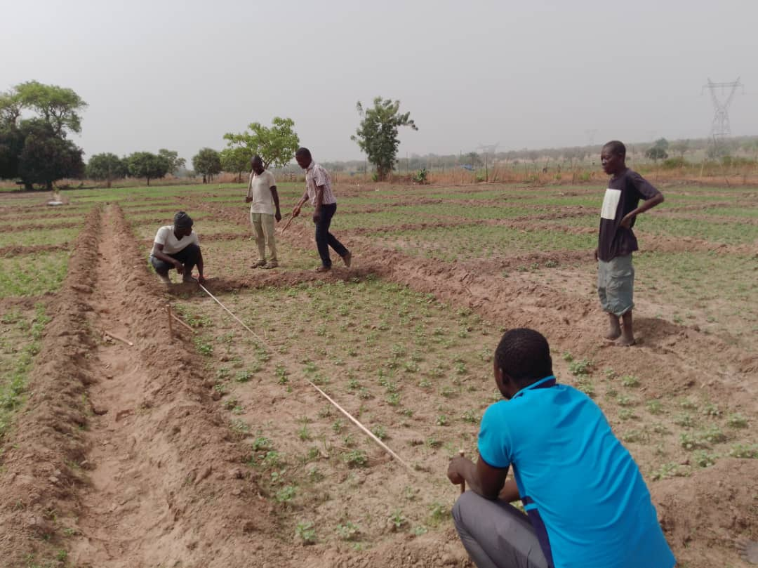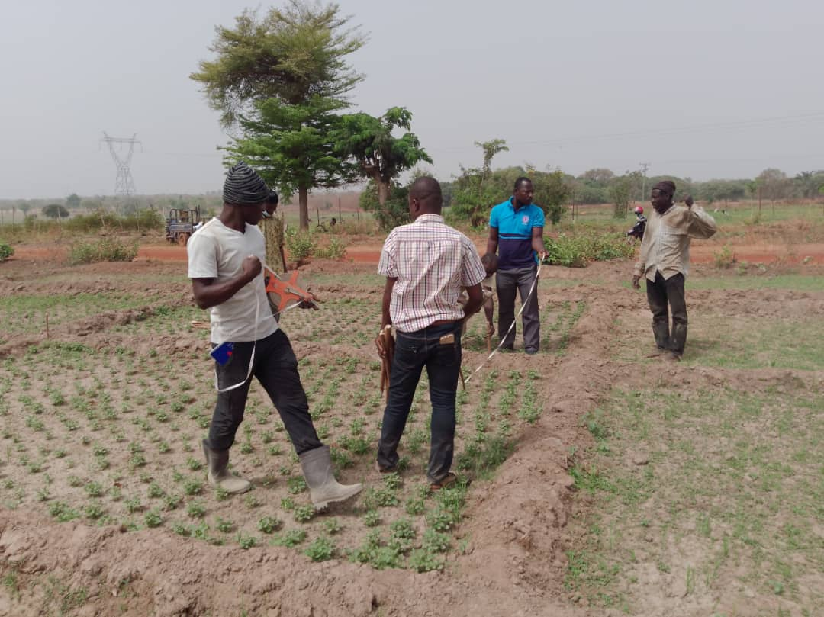
Appendix 1: Demarcation of trial plots for data collection at Libiga, Savelugu Municipality

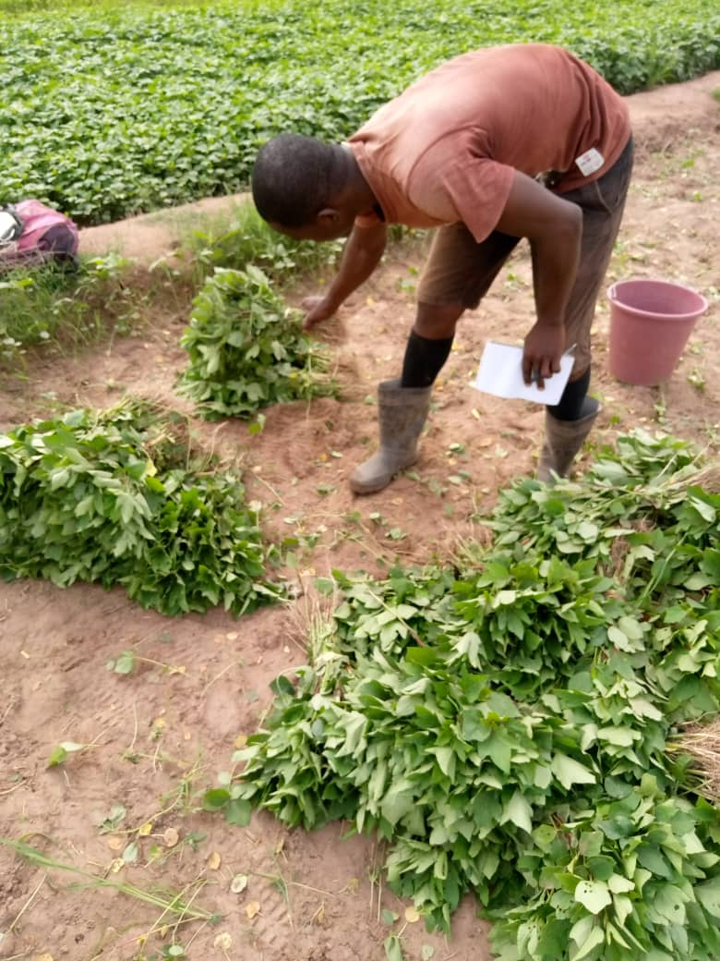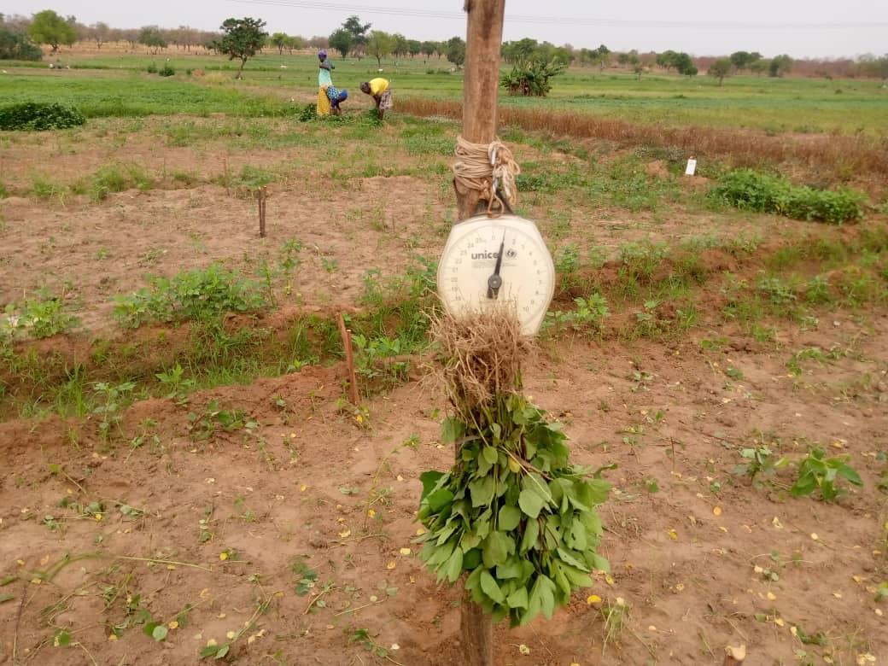
Appendix 2: Harvesting and weighing of leafy vegetables at the Libiga irrigation site.

